Foreign Minister Retno Meets Japanese Foreign Minister to Discuss Economic Cooperation and Regional Issues

Jakarta, 13 July 2023 - During the 56th ASEAN Foreign Ministers' Meeting (AMM) and Post-Ministerial Conference (PMC) in Jakarta (13/7), Indonesian Foreign Minister Retno Marsudi held a bilateral meeting with Japanese Foreign Minister Hayashi Yoshimasa. The meeting discussed strengthening bilateral economic cooperation and various regional issues.
Both Foreign Ministers welcomed the strong bilateral relations between the two countries and the ASEAN-Japan relationship. This year is an important milestone for Indonesia, ASEAN, and Japan as they commemorate 65 years of Indonesia-Japan diplomatic relations and 50 years of ASEAN-Japan relations.
Regarding the strengthening of economic cooperation, both Foreign Ministers agreed to accelerate the negotiation of the IJEPA protocol amendment as previously discussed by the two leaders. It is hoped that the negotiation can be concluded during the 43rd ASEAN Summit.
Japan reiterated its support for Indonesia's chairmanship in ASEAN and pledged to continue coordinating efforts to ensure the success of the 43rd ASEAN Summit and other related summits, including the East Asia Summit (EAS).
After 30 years, both Foreign Ministers agreed that, while continuing to strengthen Confidence Building Measures (CBM), it is time for the ASEAN Regional Forum (ARF) to discuss preventive diplomacy efforts.
Regarding the situation in the South China Sea, Foreign Minister Retno reiterated Indonesia's consistent position of upholding international law, particularly the 1982 UNCLOS.
Regarding the issue of Myanmar, Foreign Minister Retno stated that as the Chair, Indonesia has engaged intensively and extensively with all parties in Myanmar during its chairmanship for the past 7 months. In this regard, the Japanese Foreign Minister expressed appreciation and support for Indonesia's approach in addressing the issue of Myanmar. Japan supports the implementation of the 5-Point Consensus.

***

For further information, please contact the following:
Director for Information and Media of the inistry of Foreign Affairs - Hartyo Harkomoyo (+62811831899)

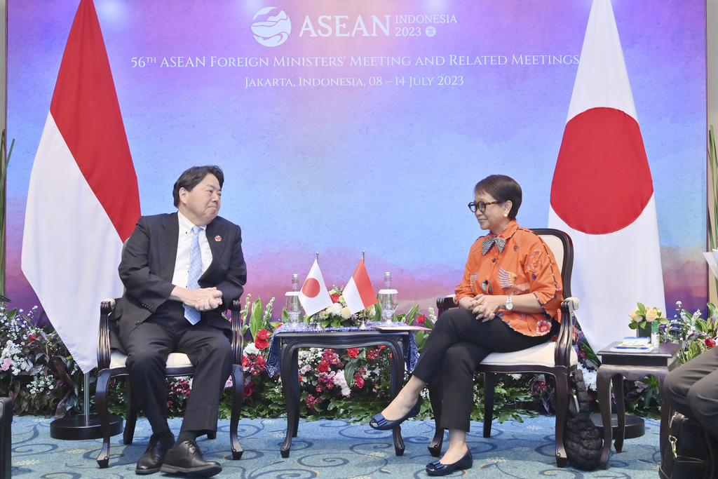

Indonesian Foreign Minister Retno Marsudi held a bilateral meeting with Japanese Foreign Minister Hayashi Yoshimasa and discussed strengthening bilateral economic cooperation and various regional issues during the 56th ASEAN Foreign Ministers' Meeting (AMM) and Post-Ministerial Conference (PMC) in Jakarta (13/7) (Photo: Ministry of Foreign Affairs of Indonesia).

